**Fire detection and Alerting system**

**Design:**

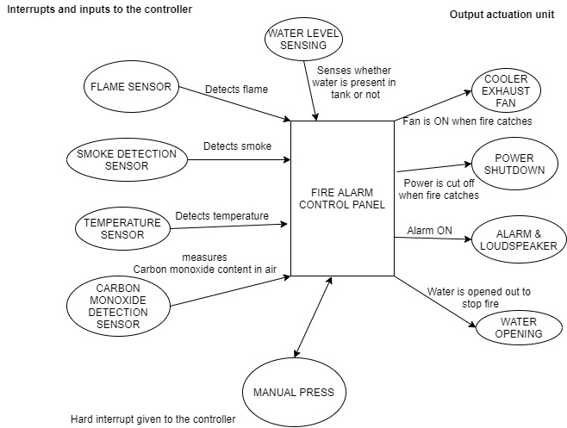

This is a simple and first level design further more can be improved as keeping different zones and finding which zone has caught fire. The system will be powered using battery.

**Functionalities:**

* Flame sensor has the highest priority that will tell whether fire has occurred or not. So, based on the sensor values and some threshold the things gets actuated which are in the right.
* When the manual press is one irrespective of any sensor values the things get actuated like water opening, cooler fan, power cut off and alarm all these gets implemented based on the priority given below.
* Water level is sensed irrespective of fire caught since the water is needed in the tank when fire is caught.

**Logic:**

Here the highest number will be the most priority one

|  |  |  |
| --- | --- | --- |
| **Tasks** | **Name** | **Priorities** |
| Task 1 | Flame sensor | 10 |
| Task 2 | Smoke sensor | 8 |
| Task 3 | Temperature sensor | 8 |
| Task 4 | Water level sensor | 10 |
| Task 5 | Alarm & Loudspeaker | 8 |
| Task 6 | Cooler ON | 7 |
| Task 7 | Water opening | 8 |
| Task 8 | Power shutdown | 8 |

**Types of fire Detection and alerting system**

* **Conventional:** It is a wired system where the building is divided into different zones and the correct zone which has got fire will be shown in the screen
* **Wireless:** These are wireless system which communicates using radio waves. This is full intelligent fire detection system which doesn’t need any cable.
* **Addressable:** Addressable is same like Conventional but all the detectors are kept in a loop given a certain address using DIP switch. And if fire catches we can get to know in the control panel that which detector has called for the alarm.
* **Intelligent:** Previous systems were not intelligent this system itself tells whether it is a fire or a fault.

**References:**

* <https://www.youtube.com/watch?v=cVjyDgFrb2g>
* <http://sspengineering.cn/en/pd.jsp?id=11>
* de Oliveira Turci, Luca. (2017). Real-Time Operating System FreeRTOS Application for Fire Alarm Project in Reduced Scale. International Journal of Computing and Digital Systems. 6. 198-204. 10.12785/IJCDS/060405.